### **Chapter 4: Defensive Driving Techniques**

### **Defensive Driving Techniques: Comprehensive and Educational Guide**

Defensive driving is a proactive approach to road safety. While following traffic rules reduces collision risks, you cannot control the behavior of other drivers. Therefore, defensive driving techniques focus on minimizing risks, anticipating hazards, and protecting yourself and others on the road.

### **What is Defensive Driving?**

Defensive driving extends beyond merely obeying traffic laws. It encompasses attitudes, habits, and strategies to:

* Handle impaired or distracted drivers.
* Navigate adverse weather conditions.
* Avoid collisions by anticipating potential hazards.

The ultimate goal is to prevent crashes and ensure everyone's safety on the road.

### **Preparation and Planning for Safety**

Defensive driving begins before you hit the road. Planning ensures you are ready to deal with potential issues, whether it’s a short commute or a long trip.

#### **Packing Essentials**

Always carry essential supplies for emergencies:

* First aid kit
* Basic car repair tools
* Flashlight and extra batteries
* Maps or GPS device
* Blanket, warm clothing, food, and water

These items can be lifesaving during breakdowns, severe weather, or remote travel.

#### **Urban Routes**

* **Timing**: Avoid rush hour to minimize delays and reduce stress.
* **Traffic Updates**: Check traffic reports to avoid collisions or construction zones.
* **Weather Preparation**: Equip your car with chains during severe weather and allow extra travel time.

#### **Planning Long Trips**

* Use maps to determine the best route and plan stops for food, restrooms, and refueling.
* Prepare for weather changes and potential detours.
* Familiarize yourself with the roads and exits to prevent confusion.



### **Avoiding Problems on the Road**

#### **Reduce Your Speed**

Driving at safe speeds improves decision-making and reaction times:

1. **Detailed Awareness**: Notice more around you and understand the situation better.
2. **Time to React**: Analyze potential risks and take action to avoid collisions.
3. **Give Others Time**: Slowing down allows other drivers to react safely as well.

### **Adjusting Speed Based on Other Drivers**

Slowing down allows you to better observe the actions of other drivers and respond to unexpected behaviors. Drivers may stop suddenly, fail to signal, or make erratic moves. Maintaining a lower speed gives you the time and space needed to avoid collisions. Furthermore, at a lower speed vehicles have lesser impact in the event of collisions.

### **Adjusting Speed Based on Road Conditions**

1. **Weather:**
   * Rain, snow, fog, or high winds can make roads slippery and visibility poor.
   * Reduce your speed to ensure traction and control. This minimizes the risk of hydroplaning or skidding.
2. **Lighting:**
   * At night, limited visibility makes it harder to see obstacles, pedestrians, or animals. Drive slower to give yourself more time to spot and react to hazards.
3. **Surface Conditions:**
   * Uneven roads, potholes, or gravel can cause you to lose control or damage your vehicle. Lower your speed to navigate safely.

### **Adjusting Speed Based on Location**

1. **School Zones:**
   * Florida law requires reducing your speed to **20 mph** when children are present or during designated hours in school zones.
   * Stay alert for school buses, pedestrians, and crossing guards. Speed violations in school zones can result in fines and penalties, as outlined in **316.008 (2023 HB 657)**.
2. **High-Risk Areas:**
   * In shopping centers, downtown areas, narrow bridges, toll plazas, alleys, and residential neighborhoods, slower speeds are necessary due to heavy pedestrian activity and tight spaces.
   * Always watch for vehicles entering or exiting driveways or parking spaces in these areas.

**Special Enforcement in School Zones:**

* + Florida counties and municipalities can use **camera-equipped radar detection devices** in school zones during specified times to monitor speed limits and enforce penalties for violations under **316.008 (2023 HB 657)**.

**Scenario: Approaching a School Zone**

You are driving in a school zone, and there are children around. Previously, you may have driven too fast or not paid attention to the specific speed limits in a school zone.

**Desired Behavioral Change**: Increased caution and awareness of school zone laws. Uphold traffic laws by watching for school buses and stopping when you are required to by law.

In Florida, it's mandatory for all drivers to stop when a school bus has its red lights flashing and stop arm extended when you are driving:

1. **On a two-lane or multi-lane undivided road**: All drivers must stop in both directions when the bus has its red lights flashing and stop arm extended.
2. **On a divided highway with a median or unpaved space (5 feet or more)**: Only drivers **behind the bus** must stop; drivers **in the opposite direction** do not need to stop.

**CARD – Click To See New Behavior**

Reduce your speed to the posted limit in the school zone, watch for children crossing, stop for school buses, and be alert for any pedestrians or school staff members directing traffic.

**Related Traffic Control Devices:**

**School Zone Speed Limit Sign:** Indicates the reduced speed limit during specific hours or when children are present.

**Crosswalks and Flashing Lights:** Alert you to the presence of children and the need for caution.

**Why It’s Important:** Florida law requires drivers to reduce speed in school zones, and failing to do so can lead to fines and points (Fla. Stat. § 316.1895). Speeding in a school zone endangers children and school staff.

### **Scanning: A Key Defensive Driving Skill**

To be a safe and effective driver, maintaining constant awareness of your surroundings is crucial. This process, called **scanning**, involves actively observing the road ahead, behind, and to the sides of your vehicle. Scanning helps identify potential hazards, anticipate problems, and react promptly to ensure safety.

### **How to Scan Effectively**

1. **Look Ahead:**
   * **Urban Areas:** Scan about a block ahead to anticipate sudden stops, signals, or obstacles.
   * Be ready to stop or change lanes if necessary, and watch for drivers who might not yield the right-of-way or make unpredictable moves.
   * Look for pedestrians, bicyclists, and other vehicles that might enter your path unexpectedly.
   * **Open Roads:** Check a quarter mile ahead to prepare for changes in traffic patterns or hazards.
2. **Check Behind:**
   * Be aware of vehicles following you. Use your rear-view mirror every 2–5 seconds.
   * Look behind before:
     + Changing lanes
     + Slowing down suddenly
     + Backing up
     + Descending steep hills
   * Monitoring your rear ensures that you can react if a car is following too closely, preventing rear-end collisions.
3. **Observe the Sides:**
   * Use your side-view mirrors and turn your head to check blind spots before making any lane changes or turns.
   * Avoid driving directly beside another vehicle, as they might not see you and could swerve into your lane unexpectedly.

### **Key Scanning Techniques**

* **Left-Right-Left Rule:** Always look **left, right, and left again** before entering an intersection or making a turn. This double-check ensures no vehicles, pedestrians, or bicycles are in your path.
* **Peripheral Awareness:** Pay attention to your surroundings, including traffic signals, signs, weather conditions, and any changes in the road's surface, like potholes or construction zones.

#### **Common Hazards to Watch For**

1. **Parked Vehicles Entering Traffic**: Look for brake lights, turning wheels, or people getting into cars.
2. **Right-of-Way Violations**: Anticipate drivers who may ignore stop signs or signals.
3. **Inattentive Drivers**: Be prepared to avoid distracted or erratic drivers.
4. **Sudden Hazards**: Cover your brakes in areas with children, pets, or high pedestrian activity.

### **Pacing and Following Distance: Maintaining Safe Driving Practices**

Maintaining appropriate pacing and following distance is crucial to ensuring safety on the road. Driving at a speed similar to surrounding traffic and leaving adequate space between vehicles helps prevent collisions and ensures that you have enough time to react to unexpected situations. Below are detailed guidelines for maintaining safe pacing and proper following distances.

### **Pacing with Traffic**

1. **Adapting to Traffic Flow:**
   * Match your speed to the flow of traffic when it is within the legal speed limit.
   * Driving significantly faster or slower than surrounding vehicles can cause confusion and increase the risk of collisions.
2. **Adhering to Speed Limits:**
   * Always obey posted speed limits, especially in areas where traffic tends to vary.
   * Adjust your speed in response to weather, road conditions, and traffic congestion as needed (FS 316.183).
3. **Slower Traffic:**
   * If you are driving slower than the flow of traffic, use the right lane whenever possible to allow faster vehicles to pass safely.

### **The Space Cushion: Creating Distance for Safety**

A **space cushion** is the buffer of distance you maintain around your vehicle to allow for sudden stops or unexpected maneuvers by others. This practice ensures safer driving by providing more time to react to hazards.

#### **The Three-Second Rule:**

* Use the "Three-Second Rule" to maintain a safe following distance:
  1. Watch the vehicle ahead pass a fixed object (e.g., a sign, overpass).
  2. Count "one-thousand-one, one-thousand-two, one-thousand-three."
  3. If you pass the fixed object before finishing the count, increase your following distance.

Under ideal driving conditions, a minimum two-second following distance may be employed.

#### **Adjusting for Weather and Vehicle Types:**

* **Standard Conditions:** A 2-second cushion is sufficient for cars or vans.
* **Motorcycles, Buses, and Trucks:** Add 1 second.
* **Tractor-Trailers:** Add 2 seconds.
* **Weather Conditions:**
  + Light rain or fog: Add 1 second.
  + Heavy rain, snow, or slippery roads: Add 2 seconds.
  + Icy conditions: Add 3 seconds or more.

(FS 316.0895 emphasizes maintaining a reasonable following distance to prevent collisions.)

### **Attitude Check: How Close is Too Close?**

Whether you're assertive, impatient, anxious, or distracted — your personality and emotions affect how you pace yourself on the road. Recognizing your default reactions is the first step toward safer driving.

**Ask yourself:**

* Do I tend to drive closer to others when I’m frustrated or rushed? Do I even notice my following distance — or am I just matching the car ahead? Would I be comfortable with someone driving that close to *me*? Respond to the prompts while noticing your attitude adjustments, and explain the safe way to pace your vehicle.

### **Personality Reflections:**

* **The Competitor** might tailgate because they hate feeling “held back.”
* **The Peacemaker** might follow too closely to avoid confrontation by passing.
* **The Anxious Driver** might not realize they’re tailgating while focused on something else.
* **The Overconfident Driver** assumes they’ll always react in time — until they don’t.

### **Key Takeaway:**

Safe following distance isn't about how you *feel* — it’s about **physics** and **reaction time**. Emotions can shorten your space — but crashes extend the consequences.

### **Maintaining and Adjusting Your Space Cushion**

1. **Traffic Entry and Merging:**
   * Ensure a four-second gap when merging or entering traffic. This allows ample space for you and other drivers to stop safely if needed.
2. **Tailgating:**
   * If a car is tailgating you, increase your space cushion to the front to avoid sudden braking incidents.
   * Avoid "brake-checking" tailgaters; instead, adjust your pace and allow them to pass when safe.
3. **Special Situations:**
   * **Heavy Loads or Trailers:** Maintain extra space for vehicles carrying heavy loads, as they require more time to stop.
   * **Blind Spots:** Stay aware of large vehicles’ blind spots, known as “No Zones,” and maintain a safe distance.
   * **Limited Visibility:** Increase following distance in fog, heavy rain, or when your view is obstructed by larger vehicles.
4. **School Buses and Railroad Crossings:**
   * When following school buses or stopping at railroad crossings, leave ample space for unexpected stops or delays.

### **Cushion to the Sides**

1. **Side Space:**
   * Maintain a buffer on both sides of your vehicle, especially in urban areas or congested traffic.
   * Avoid driving directly alongside another vehicle for extended periods, as they may suddenly swerve into your lane.
2. **Hazard Awareness:**
   * Watch for parked cars that may pull into traffic unexpectedly or have occupants opening doors.
   * Keep a safe distance from cyclists and pedestrians.

### **When Is It Appropriate to Use Your Horn?**

Your horn is a safety tool—not a way to express frustration. In Florida and across the U.S., honking should be used **only to prevent a collision or alert others to immediate danger**. For example, it’s appropriate to tap your horn to warn another driver who is drifting into your lane or to alert a pedestrian or cyclist who hasn’t seen your vehicle.

**It is not appropriate** to use your horn to show anger, scold other road users, or rush someone at a green light. Unnecessary honking can escalate tension, distract others, and even create dangerous situations.

When in doubt, ask yourself: *“Am I trying to help someone avoid harm, or just venting?”* If it’s the latter, stay calm and keep your hand off the horn. Responsible drivers use their horn **sparingly and with purpose.**

### **Understanding Blind Spots**

* **Definition:** Blind spots are areas where the driver's view is obstructed due to the vehicle's construction. Mirrors provide a limited view but cannot eliminate these blind spots entirely.
* **Checking Blind Spots:** Always turn your head to physically check blind spots before changing lanes or making maneuvers.
* **Awareness of Other Drivers:** Staying in another driver’s blind spot for an extended time increases the risk of collision, as they may not see you.

### **Blind Spots and the “No Zone”**

Blind spots are areas around a vehicle that are not visible to the driver through mirrors. These areas vary by vehicle design and pose a significant safety risk if not adequately managed. To drive safely, it is crucial to understand the blind spots around your vehicle and others, particularly larger vehicles like trucks and buses.

### **"No Zones" for Trucks and Buses**

Large vehicles like trucks and buses have larger blind spots, known as "No Zones." These areas extend:

1. **Directly Behind the Vehicle:** Large blind spots make tailgating dangerous. Drivers of these vehicles cannot see smaller cars directly behind them.
2. **On Both Sides:** Trucks and buses have significant side blind spots. If you stay in these zones, the driver may not see your car when changing lanes or turning.
3. **In Front:** Large vehicles require more distance to stop. Cutting too close in front of a truck or bus can result in a rear-end collision if they cannot stop in time.
4. **When Backing Up:** Trailers or large vehicles reversing can obscure objects in their path. Stay clear of these areas to avoid being struck.

### **Hazards of Blind Spots and "No Zones"**

#### **1. Backing Up**

* **Risk:** A truck or bus may block the roadway to reverse, with limited visibility of obstacles in the "No Zone."
* **Action:** Stay back, be patient, and avoid trying to pass behind the vehicle.

#### **2. Passing**

* **Risk:** Trucks and buses need longer distances to slow down. Passing unsafely can put you in their blind spot or in danger if you cut back too soon.
* **Action:**
  + Maintain a constant speed while passing.
  + Ensure you can see the truck or bus's front entirely in your rear-view mirror before reentering the lane.

#### **3. Rear Blind Spots**

* **Risk:** Following too closely ("tailgating") eliminates your visibility of the road ahead and increases the likelihood of a collision.
* **Action:** Leave ample space behind large vehicles to ensure visibility and reaction time.

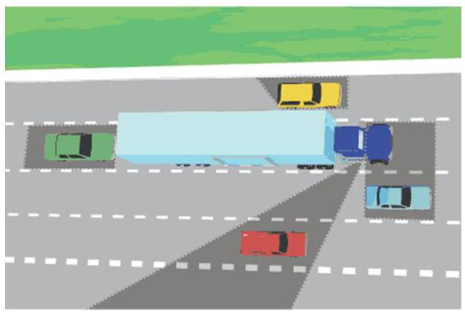

#### **4. Side Blind Spots**

* **Risk:** Trucks and buses cannot see smaller vehicles in their wide side blind spots, especially during lane changes.
* **Action:** Avoid lingering in these areas. If you must pass, do so quickly and safely.

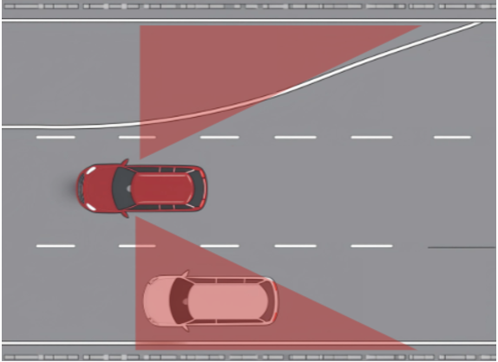

#### **5. Wide Turns**

* **Risk:** Trucks and buses often swing wide to make right turns, creating potential collision points.
* **Action:** Never attempt to squeeze between the vehicle and the curb or shoulder during a turn.

### **Driving Tips Around Large Vehicles**

* **General Rules:**
  + Avoid pulling out in front of a truck or bus and suddenly braking.
  + Stay visible by ensuring the driver can see your vehicle in their mirrors.
  + Use signals early to communicate your intentions.
* A loaded truck traveling at 55 mph on a clear, dry roadway can take up to **800 feet** to come to a complete stop.

### **Attitude Check: How Do You Respond to Big or Slow Vehicles?**

When you find yourself behind a large truck, farm vehicle, or bus moving slowly, what’s your instinct? Do you get frustrated and try to pass quickly — even when it might not be safe? Or do you recognize the risks and adjust your driving to ensure everyone's safety?

**Remember:**

* Large vehicles have wide blind spots and need more room to stop and turn.
* Impatience can lead to dangerous decisions, like passing on curves or in no-passing zones.
* Slow-moving vehicles may be legally using the road — it's your responsibility to navigate safely around them.

**Ask Yourself:**

* Do I give large vehicles enough space?
* Am I staying calm and patient, or letting frustration cloud my judgment?
* Do I understand the limitations of larger vehicles and adjust my driving accordingly?

Changing your mindset from frustration to cooperation could save lives — including your own.

### **Key Takeaways**

* **Bigger Vehicles Require More Room:** Larger vehicles have greater blind spots, need more room to maneuver, and take longer to stop or accelerate.
* **Stay Visible:** Ensure you are always visible to truck and bus drivers to avoid collisions.
* **Plan and Anticipate:** When driving near large vehicles, be mindful of their operational limitations, such as wider turns and longer stopping distances.

### By recognizing and respecting the "No Zones" around trucks and buses, you can significantly reduce the risk of collisions and improve safety for everyone on the road.

## **Scenario: “He Sees Me… Right?”**

### ***A Lesson in Assumptions, Emotions, and Blind Spots***

Jessica is a confident and fast-moving driver. She considers herself efficient, assertive, and always in control. On her morning commute, she gets stuck behind a slow-moving semi-truck in the middle lane. She’s running late, the music is loud, and her mind is already at work.

Frustrated, she darts into the right lane to pass. As she starts to accelerate, the truck’s right blinker comes on — it begins moving over. Jessica slams on the horn and brakes hard, swerving into the shoulder. She's shaken but unharmed.

### **Personality & Emotional Breakdown**

Jessica didn't break any laws — but she made **three dangerous assumptions**, shaped by her personality and mindset:

1. **The Overconfident Driver**:  
    Jessica assumed she was always visible. She didn't know that trucks have **huge blind spots on the right side**, often called the “no zone.”
2. **The Impatient Driver**:  
    Her frustration and time pressure made her ignore signs the truck was preparing to change lanes.
3. **The Emotion-Driven Mover**:  
    Her need to “stay in control” clouded her judgment, leading her to act based on **emotion, not awareness**.

### **Key Insight**

Most truck-related crashes are caused by passenger vehicle drivers who **underestimate blind spots, stopping distances, or turning space**.  
 According to the FMCSA, **1 in 3 fatal crashes involving a large truck happens in a blind spot area** (FMCSA, 2023).

### **Reflective Prompt**

* Have you ever assumed a large truck could see you — and been wrong?
* Do you ever make moves based on being “in a rush” or “fed up” rather than staying safe?
* What part of your personality influences how close you follow or how soon you try to pass?

### **Commitment Pledge**

*I pledge to respect the space and limitations of large trucks. I will stay out of blind spots, avoid passing on the right, and check my emotions before making decisions around commercial vehicles. My safety is more important than getting ahead.*

**✓ CLICK TO COMMIT**

#### **Keep a Safe Distance**

Maintain a safe following distance to allow for the truck's longer braking time. It can take them more than 800 feet to stop at 55 MPH. Tailgating is illegal. Avoid tailgating to reduce the risk of a collision.

#### **Avoid Sudden Maneuvers**

Trucks need more time to stop or change lanes. Don’t cut them off or make abrupt movements nearby.

#### **Pass Safely**

* Always pass on the left side where visibility is better.
* Signal clearly and move past promptly.
* Ensure you see the truck's front in your rearview mirror before returning to the lane.

#### **Give Space for Turns**

Trucks require extra room to turn, especially to the right. Never position your vehicle between a turning truck and the curb.

By staying visible and giving trucks the space they need, you contribute to safer roads for all drivers.

**Backing and Turning Safely**

### **Backing**

Backing up requires careful attention, as it involves driving in a direction that reduces visibility and introduces a higher risk of collisions. Objects, pets, or children can be hidden from view, so taking deliberate steps is essential for safety.

#### **Steps for Backing Up**

1. **Before Entering Your Vehicle:**
   * Walk around your car to check for obstacles such as children, pets, or objects that might be in your path.
   * Inspect tires for any issues.
2. **Check Mirrors and Surroundings:**
   * Use mirrors to identify areas around your vehicle.
   * Physically turn your head to look through the rear window for better visibility.
3. **Begin Reversing Slowly:**
   * Press the brake, shift into reverse, and gradually release the brake while maintaining control.
   * Always keep looking over your shoulder to ensure a clear path.
4. **Go at a Walking Pace:**
   * Drive slowly, as this allows more time to react to sudden hazards.
   * If backing around a corner, consider driving around the block instead or ask someone to guide you.

### **Attitude Check: Are You Rushing or Thinking When You Back Up or Pass?**

Backing up without checking your surroundings. Passing because you’re in a hurry, not because it’s safe. These aren’t just risky moves — they’re signs of a mindset that prioritizes convenience over caution.

**Quick reminders:**

* Most backing crashes happen because drivers *assume* the path is clear.
* Passing without enough space or visibility can turn a small error into a fatal crash.
* Impatience behind the wheel is one of the fastest routes to a collision.

**Check Yourself:**

* Do I treat backing up like a routine move, or do I take the time to look carefully in all directions?
* When I pass another vehicle, is it based on *need* and *safety* — or on *impatience* and *pressure*?
* Am I fully aware of my blind spots and my vehicle’s limits?

Safe driving isn’t just about knowing the rules. It’s about *choosing* not to cut corners when nobody's watching.

### **Turning**

Turning is one of the most frequent maneuvers on the road and requires planning, signaling, and awareness of other road users to ensure safety. Florida Statute 316.155 requires the use of turn signals when turning or changing lanes. Failure to signal can lead to confusion, misinterpretation, and potential collisions.

#### **Steps for Turning**

1. **Plan Ahead:**
   * Decide early where you need to turn.
   * Get into the correct lane and signal at least 100 feet before the turn, as required by law.
2. **Clear the Path:**
   * Check for pedestrians, cyclists, or other vehicles.
   * Stop if necessary to ensure the way is safe before proceeding.
3. **Execute the Turn:**
   * Use the **push-pull method** to control the steering wheel.
   * Maintain a steady speed and avoid sudden movements.

### **Right Turns**

* **Preparation:** Move close to the right edge of the road.
* **Execution:** Signal 100 feet before the turn, check for pedestrians and cyclists, and proceed when safe.
* **Avoid Wide Turns:** Stay within the correct lane and avoid drifting into other lanes.
* **Bike Lanes:** Merge into the bike lane no more than 200 feet before the turn.
* If you are turning right at a red light, you must come to a full stop and ensure that right turns on red lights are not prohibited by posted signs:

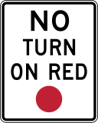

### **Scenario: Just Barely Made It**

Alex is running late—again. As he approaches an intersection, the light turns yellow. He speeds up and clears it just as the signal turns red. A few blocks later he reaches another red light with a **“No Turn on Red”** sign. He checks for the police, sees no cars coming, and turns anyway.

**What Alex doesn’t see:** A pedestrian has stepped into the crosswalk, assuming traffic will obey the light. They are nearly hit.

### **Attitude Check: What’s Behind the Habit?**

Running red lights or rushing through red-light turns isn’t about “saving time”—it’s about mindset. For many drivers it becomes an unnoticed habit, but every risky decision is still a choice:

* Do I value a few seconds more than someone’s safety?
* Am I really in control if I break rules without thinking?
* What example am I setting—for my kids, for other drivers, for myself?

### **Why This Matters Right Now**

In **2022, 1,149 people were killed and more than 107,000 injured in crashes involving red-light running—about half of those killed were pedestrians, bicyclists, or occupants of other vehicles hit by the violator (IIHS, 2024).** [IIHS](https://www.iihs.org/topics/red-light-running)

### **What’s Driving You?**

| **Personality / Emotion** | **Risky Red-Light Habit** | **Safer Replacement** |
| --- | --- | --- |
| **Always Rushing** | Accelerate on yellow or roll through “No Turn on Red” | Build extra travel time; treat yellow as “prepare to stop.” |
| **Feeling Entitled** | Treat lights as “suggestions” when the road looks clear | Remember intersections are shared spaces with hidden users (pedestrians, cyclists). |
| **Normalizing Risk** | “I’ve done this for years; nothing happened.” | Ask: *How lucky do I want to keep relying on luck?* |

### **Commit to a One-Week Challenge, Then Keep It Going**

1. **Full Stop, Every Time:** Red means *complete* stop—no creeping turns until legal and clear.
2. **Yellow = Slow, Not Go:** If you can stop safely when the light turns yellow, do it.
3. **Track Your Stress:** Note how your stress level changes when you stop rushing.
4. **Celebrate the Wins:** Every red light obeyed is a positive habit reinforced.

### **Key Takeaway**

You’re not “just bending a rule.” Each red-light violation breaks the trust of every pedestrian, cyclist, and driver who counts on you to stop. **Choose safety—stop on red, every time.**

### **Left Turns**

* **Preparation:** Position close to the center divider or left turn lane.
* **Execution:** Signal, check left-right-left for traffic, and turn only when safe. Keep wheels straight while waiting to avoid being pushed into oncoming traffic in a collision.
* **Left Turn on Red:** Allowed only from one-way streets to another one-way street after yielding to traffic and pedestrians.

### **Protected and Unprotected Turns**

* **Protected Turns:** Wait for a green arrow to proceed, ensuring no other vehicles or pedestrians are crossing.
* **Unprotected Turns:** Yield to oncoming traffic and make the turn only when safe.

### **U-Turns**

A **U-turn** allows drivers to reverse direction but carries significant risks, including reduced visibility and proximity to oncoming traffic. Always ensure it is legal and safe before making a U-turn.

### **Risks of Improper Turns**

* **Sudden Decisions:** Making unplanned U-turns can endanger pedestrians, cyclists, and motorcyclists.
* **Scanning:** Always check for intersections, roads, or vehicles that may conflict with your path.
* **Emergency Vehicles:** Ensure you are not obstructing or unaware of approaching emergency vehicles.

### **Passing Safely: Guidelines and Best Practices**

### **Passing is an essential but potentially dangerous maneuver. It requires situational awareness, adherence to traffic laws, and careful planning. This guide provides an overview of when and how to pass safely while following legal and safety standards.**

### **General Guidelines for Passing**

### **When to Pass:**

### **Pass only when road signs or markings permit.**

### **Ensure the conditions allow for a safe and complete maneuver.**

### **Pass only one vehicle at a time to minimize risk.**

### **Use your turn signal to communicate your intentions clearly.**

### **Where to Pass:**

### **On multi-lane roads, use the left lane to pass slower vehicles and return to the right lane after completing the pass.**

### **On two-lane highways, ensure ample space and time to pass without endangering oncoming traffic.**

### **Judgment:**

### **Do not pass when you are tired, distracted, or upset, as it increases the likelihood of errors.**

### **Assess road conditions, visibility, and traffic patterns before attempting to pass.**

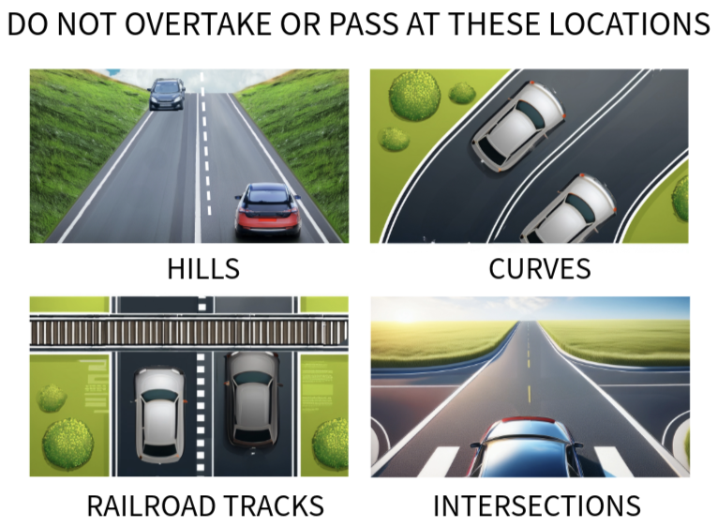

**Safe Passing Distance**

When overtaking any vehicle, Florida law (**Florida Statute 316.083**) requires drivers to pass to the left at a **safe distance** and not return to the right side until they are safely clear of the overtaken vehicle. For bicycles and other nonmotorized vehicles, a **minimum of 3 feet** must be maintained. When passing larger vehicles, such as trucks, ensure sufficient space to account for their longer stopping distances and blind spots. Always return to your lane only when it is safe and clear of the overtaken vehicle.

**Scenario: Overtaking Another Vehicle on a Two-Lane Road**

You are driving behind a slower vehicle and decide to pass them on a two-lane road. In the past, you might have passed without checking for oncoming traffic or ensuring the passing lane was clear.

**Desired Behavioral Change:** Caution and safe overtaking.

**CARD – Click To See New Behavior**

Think about what you have read so far about passing. Make a checklist or plan, with all the steps and considerations for passing safely.

**Related Traffic Control Devices:**

Passing Zone Sign (Regulatory Sign): Indicates areas where passing is allowed.

Double Yellow Lines (Pavement Marking): Indicates that passing is prohibited.

**Related Hazards:**

Curves, hills, low visibility (for example: fog, heavy rain, darkness, or bright sunlight), fast-moving opposing traffic. If these hazards are present, do not attempt to overtake a vehicle.

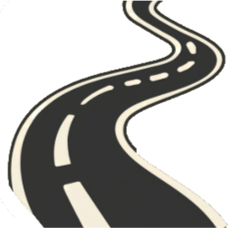

**Why It’s Important:** Passing unsafely can lead to head-on collisions or traffic violations (Fla. Stat. § 316.084). Head-on collisions are very serious and often lead to fatalities. Ensuring that it’s safe to pass prevents collisions and ensures that you’re not violating traffic laws.

### **Legal Considerations**

#### **When Passing is Illegal**

### **Hills and Curves: Never pass on hills or curves where visibility is limited.**

### **Railroad Crossings: Do not pass near or at railroad crossings.**

### **Bridges and Tunnels: Avoid passing within 100 feet of bridges, viaducts, or tunnels.**

### **School Buses: Do not pass a stopped school bus with flashing red lights; severe penalties apply.**

### **No-Passing Zones: Obey all no-passing zones marked by signs or solid yellow lines on your side of the road.**

### **Blind Intersections: Do not pass near blind intersections or areas with obstructed views.**

### **Crowded Traffic: Avoid passing if there is a long line of vehicles ahead or heavy oncoming traffic.**

Florida law prohibits passing on the shoulder (FS 316.084).

### **Techniques for Safe Passing**

#### **On Multi-Lane Roads:**

### **Signal your intention to pass well in advance.**

### **Check mirrors and blind spots before moving into the left lane.**

### **Maintain a consistent speed; avoid accelerating excessively.**

### **Return to the right lane only when you see the vehicle you passed in your rearview mirror.**

#### **On Two-Lane Highways:**

### **Ensure at least a 10-second gap in oncoming traffic, as passing at 55 mph requires over 1600 feet of clear road.**

### **Stay a safe distance behind the vehicle you plan to pass to improve visibility.**

### **Use your horn or flash your headlights to signal your intent to pass when necessary.**

#### **Passing Safely:**

### **Always check your blind spots and ensure the passing lane is clear.**

### **Do not rely on other drivers to make room for you.**

### **Return to your original lane only when it is safe and without cutting off the vehicle you passed.**

* **Do not attempt to pass more than one vehicle at once. Predicting the actions of multiple drivers at once increases the chances of a collision and hinders your ability to return safely to the lane.**
* **Always use your signals to let other drivers know your intentions**

#### **Avoid These Passing Mistakes – Click To Learn More**:

### **Passing on the right side or the shoulder, which is illegal and dangerous.**

### **Attempting to pass multiple vehicles at once.**

### **Misjudging the speed or distance of oncoming vehicles.**

### **Being Passed**

### **When another driver attempts to pass you:**

### **Maintain a steady speed and avoid accelerating.**

### **Move to the right side of your lane to give them extra room.**

### **Allow the other vehicle to pass safely without interference.**

### **Scenario: Don’t Be *That* Driver**

Jason is driving on a two-lane rural highway. He notices a car behind him getting closer. Even though the speed limit is 55 mph, Jason has been going about 50. As the car begins to pass, Jason speeds up slightly — not because he wants to go faster, but because he doesn’t like the idea of someone getting ahead of him. The car now struggles to pass, stuck in the oncoming lane with limited visibility ahead. Jason keeps accelerating. The car finally merges back behind him, frustrated and potentially endangered.

**What went wrong?**

Jason made a dangerous and selfish decision. Drivers being passed have a legal and moral responsibility not to interfere. Speeding up while being passed increases the risk of head-on collisions and road rage incidents. It’s not just inconsiderate — it’s *reckless*.

### **Reflection Questions:**

* Have you ever reacted like Jason when someone tried to pass you?
* What might motivate a driver to do this — and what are the consequences?
* What should Jason have done differently?

**Key Takeaway:**When someone passes you, your job is simple: **maintain your speed or slow down slightly** to let them pass safely. Road safety is not a competition. By allowing someone to pass, you are prioritizing safety over speed or convenience, and this reflects patience, responsibility, and maturity.

### **Special Situations**

### **Space to Merge:**

### **Leave at least a four-second gap when merging into traffic. This buffer gives you and other drivers time to react.**

### **Passing on Hills or Curves:**

### **Pass only if you can see at least one-third of a mile ahead.**

### **Stay in your lane on curves or hills, as edging left for a better view is highly unsafe.**

### **Blind Spots and Visibility:**

### **Avoid passing large vehicles like trucks or buses in their blind spots.**

### **Use extra caution when visibility is reduced by weather or other conditions.**

#### **Traffic Breaks**

When law enforcement performs a traffic break:

* Turn on hazard lights and reduce speed gradually.
* Do not pass the patrol vehicle until the break ends.

### **Scenario: Confusion in a Traffic Break**

It’s a busy afternoon on the freeway. Suddenly, drivers notice a patrol car weaving side to side across all lanes with its lights flashing — a traffic break. Most drivers begin to slow down and create space, but several don’t understand what’s happening. One driver, Angela, impatiently changes lanes and speeds up to pass the patrol car. Another driver slams on the brakes out of panic, nearly causing a rear-end collision. A third tries to follow Angela, thinking the patrol car is just "moving out of the way."

**What went wrong?**

Angela ignored the traffic break and risked her life — and the lives of others. The purpose of a traffic break is to slow or stop vehicles so officers can safely clear hazards, assist stranded motorists, or manage an emergency ahead. Disregarding these signals puts everyone at risk and is *illegal*.

**Slamming on the brakes** or acting without understanding the situation can also be dangerous. Traffic breaks require calm, attentive driving — not panic or aggression.

### **Reflection Questions:**

* Do you know what a traffic break looks like?
* Have you ever seen one and not been sure what to do?
* Would you know how to respond calmly and legally at that moment?

**Key Takeaway:**When you see a law enforcement vehicle weaving with flashing lights, **slow down safely and stay behind it**. It's there to protect you — not to delay you.

### **Lane Changes and Usage**

Changing lanes is a common maneuver, essential for entering or exiting roadways, passing slower vehicles, or avoiding obstacles. Safe lane changes require awareness, communication, and smooth execution to ensure the safety of all road users. Additionally, proper lane usage is critical to maintaining traffic flow and reducing the risk of collisions.

### **Scenario: The Weaving Driver**

It’s rush hour, and traffic is moving — just not fast enough for Marcus. Frustrated, he begins weaving between lanes, darting into any small gap he sees. He barely signals, forces other drivers to brake, and cuts off a delivery van. He doesn’t realize someone behind him had to swerve to avoid a rear-end collision. A few cars honk, but Marcus just shrugs — he thinks he’s "just getting ahead."

**What’s the harm?** Aggressive lane weaving might save a minute — or cost a life. It breaks the flow of traffic, increases crash risk, and raises stress for everyone around. Drivers like Marcus create chain reactions: sudden braking, close calls, and sometimes serious crashes.

### **Attitude Check: What Kind of Driver Are You?**

We all bring parts of our personality into the driver’s seat. Are you competitive? Impatient? Easily frustrated? Or calm and steady, even when others aren't?

* **If you’re driven by urgency**, recognize that driving isn’t a race — and your safety isn’t worth shaving off a few minutes.
* **If you’re assertive by nature**, channel that into alert, proactive driving — not aggressive moves that push others out.
* **If you value control**, remember that true control means thinking ahead, not reacting impulsively.

**Being honest about your personality can help you become a safer driver.**

### **Key Takeaway:**

Driving safely isn’t about your mood or personality, it’s about choosing to *protect yourself and others*. The road is not the place to “prove a point.” Driving aggressively isn’t “skilled driving” — it’s **reckless**. Staying in your lane and going with the flow isn’t just safer, it’s smarter.

### **Steps for a Safe Lane Change**

1. **Signal Your Intentions:**
   * Use your turn signal at least 100 feet before changing lanes, as required by law.
   * If your signals are not working, use hand signals to communicate your intent.
2. **Check Your Mirrors:**
   * Look in your rearview and side mirrors to ensure no vehicles are close or in your intended path.

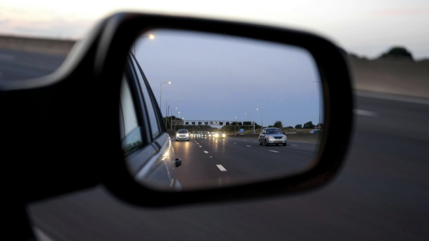

1. **Check Blind Spots:**
   * Turn your head briefly to check blind spots on the side you plan to move toward.
   * Avoid looking away from the road ahead for more than an instant to maintain awareness of traffic in front of you.
2. **Monitor Surrounding Traffic:**
   * Ensure no vehicles are attempting to pass you in the lane you intend to enter.
   * Check the far lane (if applicable) to avoid conflicts with vehicles planning similar movements.
3. **One Lane at a Time:**
   * If you need to cross multiple lanes, change one lane at a time, ensuring safety and space at each step.
4. **Finalize the Lane Change:**
   * Recheck blind spots and mirrors immediately before moving.
   * Smoothly steer into the new lane without sudden movements.

Hand Signal Refresher (For Bikers and Drivers When Necessary)

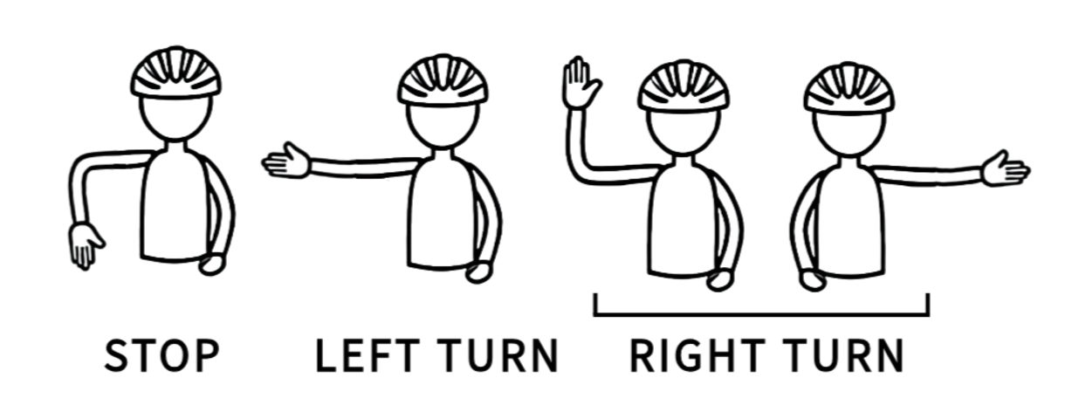

### **Common Lane Change Mistakes to Avoid**

* **Sudden Slowing:** Avoid slowing excessively, as it can confuse or disrupt other drivers.
* **Prolonged Signals:** Do not leave your turn signal on after completing a lane change, as it can mislead others.
* **Crossing Multiple Lanes:** Never veer across several lanes in one move to make an exit; if you miss your exit, proceed to the next one.
* Never attempt to change lanes at an intersection or a curve where visibility is decreased.

### **Scenario: Managing Lane Changes on Multi-Lane Roads**

You need to change lanes on a busy multi-lane road. In the past, you may have made lane changes without using your turn signal or checking your blind spots.

**Desired Behavioral Change**: **Proper lane change procedures**.

**CARD – Click To See New Behavior**

**Use your turn signal** before changing lanes and **check your mirrors** and blind spots to ensure the lane is clear. Change lanes gradually and only when it’s safe to do so, paying attention to any lane markings that may prohibit changing lanes.

**Related Traffic Control Devices**:

**Lane Change Markings**: Indicate where and when you can change lanes. When it is safe to do so, you can change lanes when there is a broken white line. Solid white lines indicate that changing lanes is discouraged, and solid yellow lines indicate that changing lanes or passing is prohibited. Double yellow lines prohibit passing.

**Turn Signal:** Required by law when changing lanes or turning (Fla. Stat. § 316.155).

**Why It’s Important**: Failing to signal or check your surroundings when changing lanes can lead to collisions and **traffic violations**. Proper procedures ensure that you don’t create hazards for yourself or others.

### **Lane Usage Rules**

Proper lane usage helps maintain traffic flow and ensures road safety. When no specific signs or markings indicate otherwise, follow these general guidelines:

1. **Stay Centered:**
   * Remain in the middle of your lane and avoid weaving unless necessary.
2. **Right-Hand Side of the Road:**
   * On most roads, stay on the right unless passing, turning, or avoiding an obstacle.
3. **Lane Designations:**
   * **Right Lane:** For slow-moving traffic or exiting vehicles.
   * **Middle Lane:** For through traffic.
   * **Left Lane:** For passing and faster-moving vehicles.
4. **Allow Faster Traffic to Pass:**
   * If driving slower than other vehicles, move to the right lane or pull over if necessary.
5. **Divided Highways:**
   * Stay to the right of barriers or dividers unless directed otherwise.
6. **Two-Lane Highways:**
   * If five or more vehicles are trailing behind you, safely pull over and allow them to pass.

### **Special Considerations**

* **Tailgating:** Leave extra space between you and the vehicle ahead when changing lanes.
* **Obstacles and Construction:** Slow down and follow designated lanes marked for construction zones or detours.
* **Merging:** Ensure adequate space when merging into traffic, aiming for a 4-second gap.

By adhering to these practices, you can navigate lane changes and roadways safely and efficiently, reducing the risk of collisions and promoting smoother traffic flow.

### **Driving With Headlights**

Using headlights during the day enhances visibility and reduces the likelihood of collisions by making your vehicle more noticeable to other drivers. This practice is especially important in poor weather conditions such as fog, rain, or snow.

#### **Legal Requirements**

* **Florida Statutes §316.217:** Requires drivers to use headlights during periods of low visibility, including rain, fog, smoke, or at any time when visibility is less than 1,000 feet.

#### **Best Practices**

* Use **low beams** during the day to avoid distracting other drivers.
* Always activate headlights during adverse weather conditions or in areas with reduced visibility.
* Consider using headlights even in clear weather to increase your vehicle's visibility to others.

Employing headlights during daytime, and at night of course, driving is a simple precaution that promotes safety and helps prevent collisions.

### **Emergency Vehicles and the Move Over Act (FS 316.126)**

Emergency vehicles, including ambulances, fire trucks, and police cars, are equipped with **sirens and lights** to signal their right of way during emergency responses. Florida laws ensure that other road users prioritize these vehicles to avoid delays in critical assistance.

#### **Driver Responsibilities When Approached by Emergency Vehicles**

Under **Florida Statute 316.126**, drivers must:

1. **Pull Over:**
   * Safely move to the nearest edge of the road to allow the emergency vehicle to pass.
   * Ensure the lane is clear of intersections and obstructions.
2. **Come to a Complete Stop:**
   * Remain stationary until the emergency vehicle has passed or the siren is no longer audible.

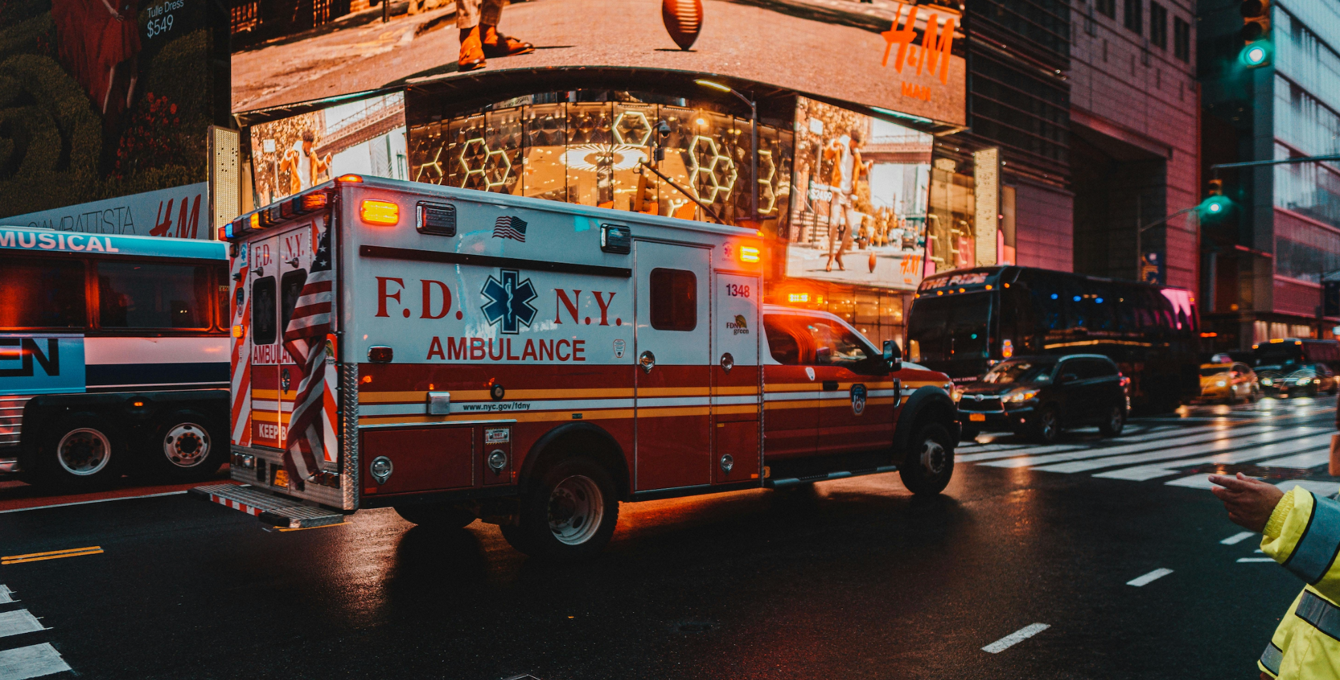

**Penalties:**Failing to yield to emergency vehicles can result in fines, points on your driving record, and potential license suspension.

#### **Florida’s Move Over Act (FS 316.126 b2)**

This act requires drivers to take precautions when approaching stationary vehicles with flashing lights or warning signals, including emergency, utility, or disabled vehicles.

1. **Slow Down:**
   * Reduce speed by **20 mph below the posted speed limit** on roads with higher speed limits.
   * On roads with a speed limit of 20 mph or less, reduce speed to **5 mph**.
2. **Move Over (When Safe):**
   * Shift into a lane away from the stopped vehicle if possible.
3. **Expanded Protections (2023 HB 287):**The law now includes requirements for:
   * Disabled vehicles with **warning lights**, hazard lights, or emergency flares/signage.
   * Vehicles with visible individuals outside, such as those changing a tire.

#### **General Tips for Complying with Emergency Situations**

* **Stay Alert:** Watch for flashing lights or hear sirens early to react promptly.
* **Avoid Blocking Intersections:** Ensure the emergency vehicle has a clear path through traffic.
* **Never Tailgate:** Avoid following emergency vehicles closely as they navigate traffic.
* **Be Patient:** Delaying your journey slightly can save lives in emergencies.

**Important:**Failing to comply with these rules not only endangers lives but can also lead to **stiff fines** and **license penalties** under Florida law.

By adhering to the **Move Over Act** and **emergency vehicle protocols**, drivers play a crucial role in ensuring the safety and efficiency of emergency response teams.

**4.5**

### **Compliance with Orders from Authorities and Flaggers**

In Florida, it is mandatory to comply with the instructions of police officers, firefighters, traffic officers, flaggers, and other authorized personnel responsible for directing traffic. These individuals are often present during **collisions, emergencies, work zones, hazardous conditions, or signal malfunctions** to ensure safety and regulate the flow of traffic.

#### **Manual Traffic Direction (FS 316.078)**

In cases where detours or alternative routes are marked, it is **illegal** to:

* Ignore detour signs.
* Drive through, tear down, or deface such signs.

These detour routes are implemented for public safety, often in areas unsafe or inaccessible due to emergencies or construction. Always follow detour signs, even if they appear inconvenient, to avoid penalties and ensure everyone's safety.

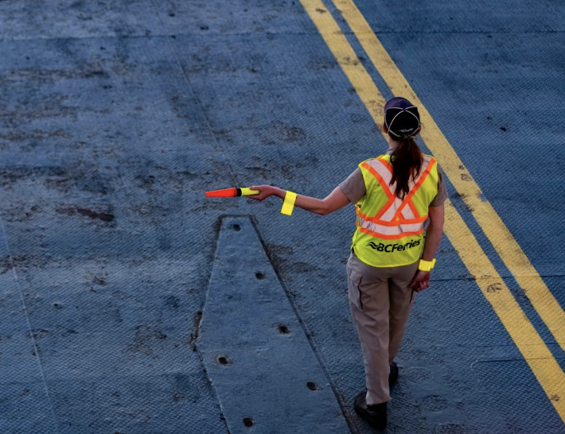

#### **Obedience to Officials and Crossing Guards (FS 316.074)**

Drivers must comply with any orders, signals, or directions given by:

1. **Traffic Officers or Emergency Responders:**
   * If directed to stop, slow down, or change course, you must follow their instructions—even if they contradict posted signs or traffic signals.
2. **School Crossing Guards:**
   * Crossing guards have the authority to control traffic near schools. Drivers must comply with their instructions to ensure the safety of children.

Failing to follow these instructions is a direct violation of Florida law and can result in fines or other penalties.

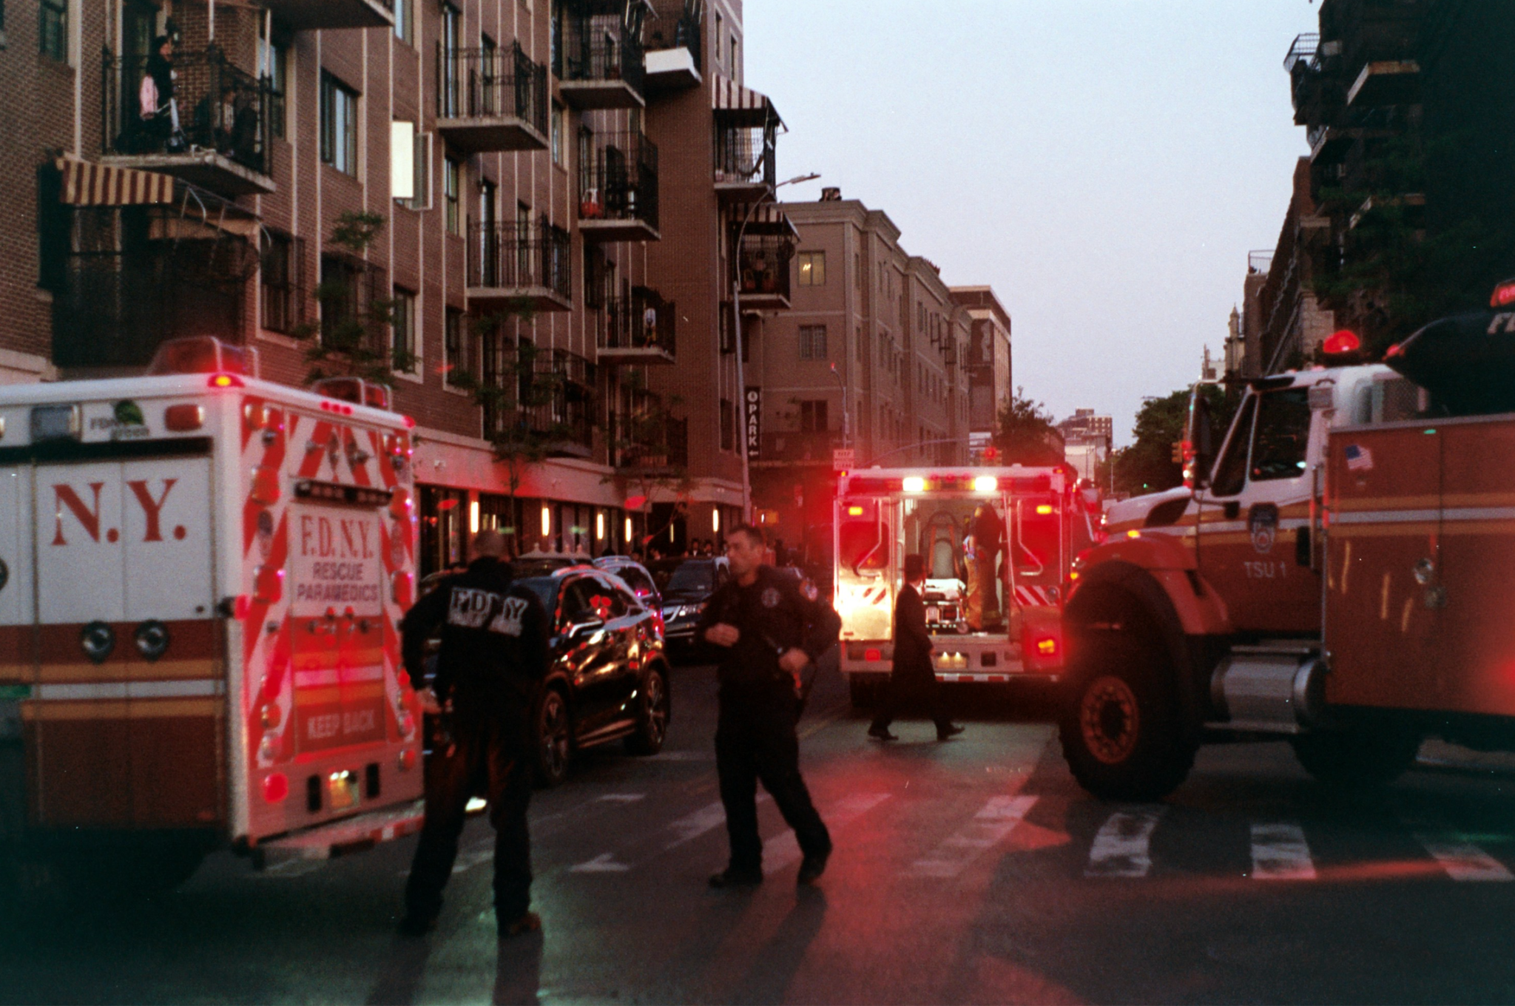

#### **Volunteer Emergency Vehicles (FS 316.2398)**

Certain individuals, such as **volunteer firefighters** and **physicians**, may use **red warning signals** on their personal vehicles when responding to emergencies.

* **Driver Responsibility:** Yield the right of way and allow these vehicles to pass.

These vehicles are legally permitted to use warning signals to ensure prompt responses during emergencies, and failure to yield can impede critical assistance efforts.

#### **Following Instructions and Signs in Construction Zones (FS 316.078)**

Drivers must obey all posted signs and the instructions of traffic flaggers or personnel managing traffic in construction areas. Signs may include:

* Reduced speed limits.
* Lane closures or shifts.
* Detours directing traffic away from the work zone.

Ignoring these signs or instructions is not only illegal but also endangers workers and other road users. Fines for violations are often doubled in construction zones, emphasizing the importance of compliance.

#### **Hazards in Construction Zones**

Construction zones may present unique hazards such as:

* **Uneven pavement or loose gravel.**
* **Narrow or shifting lanes.**
* **Presence of heavy equipment and workers close to traffic.**

Drivers should slow down, stay vigilant, and avoid distractions such as texting or adjusting controls while navigating these areas.

### **Key Points for Drivers**

* Always follow instructions from authorized personnel, even if they override existing traffic laws or signals.
* Obey detour signs and avoid interfering with traffic management measures.
* Yield to vehicles displaying red warning signals used by authorized individuals en route to emergencies.

By adhering to these laws, drivers contribute to a safer and more efficient traffic flow in critical situations, protecting lives and minimizing disruptions.

#### **Railroad Crossings**

Navigating railroad crossings safely is critical for all road users, as trains cannot stop quickly and collisions often result in severe consequences. Below is a guide to understanding railroad crossing laws, safety precautions, and signs you might encounter.

#### **General Rules for Railroad Crossings**

* **Crossbuck Signs:** These white, black-lettered signs are placed at most crossings and function as yield signs. Drivers must slow down, look for trains, and yield to oncoming trains.
* **Flashing Red Lights and Bells:** Stop immediately when these signals activate. Do not proceed until the lights stop flashing and the crossing is clear.
* **Automatic Gates:** Gates lower to block the roadway when a train is approaching. It is illegal to drive around or under closed gates (FS 316.1575).

#### **Stopping Distance Requirements**

* Drivers and pedestrians must stop at least **15 feet but not more than 50 feet** from the nearest rail when:
  1. Flashing lights or bells are active.
  2. A crossing gate is lowered.
  3. A train is visible or audible near the crossing.
* Never stop on the tracks, even in heavy traffic. Ensure there is enough room to clear the tracks completely before proceeding.

#### **Approaching Railroad Crossings Without Warning Devices**

* Slow to **15 mph** within **100 feet** of the crossing and stop completely if necessary.
* Look and listen for approaching trains from at least 400 feet away before crossing.
* Proceed cautiously if the tracks are clear.

#### **Special Situations**

* **Multiple Tracks:** Check for trains on all tracks before proceeding. Another train might be approaching even after one has passed.
* **Manual Transmissions:** Avoid shifting gears while on the tracks to prevent stalling.
* **Exempt Tracks:** Some tracks marked as "exempt" are rarely used but should still be approached with caution.

### **Scenario: Approaching a Railroad Crossing**

You approach a railroad crossing with flashing lights and barriers coming down. You may have previously failed to stop in time or misjudged the train’s arrival.

**Desired Behavioral Change**: **Complete stop and full awareness**.

**CARD – Click To See New Behavior**

Always **stop at the railroad tracks** when you see flashing lights or lowering barriers, even if the train appears to be far away. Wait until the lights stop flashing and the barriers are fully raised before proceeding.

**Why It’s Important**: Failing to stop at railroad crossings can result in **severe collisions** and legal consequences (Fla. Stat. § 316.1575). Always exercise caution when approaching these intersections.

#### **Vehicles That Must Stop at Crossings**

* **Buses and Trucks:** By law, buses and trucks carrying hazardous materials must stop within 50 feet but no less than 15 feet from the tracks, even if warning signals are inactive. Exercise caution when driving behind these vehicles, as they will stop at all railroad crossings.

#### **Types of Railroad Signs and Signals**

1. **Pavement Markings:**
   * Pavement markings with an "RXR" symbol and a stop line indicate the approach to a crossing.
2. **Advance Warning Signs:**
   * Circular yellow signs with "RXR" inform drivers to slow down, look, and listen for trains.
3. **Crossbuck Signs:**
   * White "X" signs at the crossing require drivers to yield the right of way to trains.
4. **Flashing Red Lights and Bells:**
   * Stop and remain stopped until all signals deactivate and the crossing is clear.
5. **Automatic Gates:**
   * Stop when gates lower. Do not proceed until the gates are fully raised, and the lights stop flashing.

#### **Emergency Procedures**

If your vehicle stalls on the tracks:

1. Exit the vehicle and move away from the tracks, heading in the direction of the oncoming train. This minimizes the risk of being hit by debris from the collision.
2. Contact emergency services to report the stalled vehicle.

#### **Why Safety Matters**

Trains require significant distances to stop. For example:

* A freight train traveling at **30 mph** needs over **half a mile** to come to a complete stop.
* At higher speeds, stopping distances can exceed **one and a half miles**.

Collisions with trains are nearly always catastrophic, emphasizing the importance of these rules.

#### **Legal Requirements**

According to Florida Statutes **316.1575**:

* It is illegal to drive through, around, or under a lowered gate.
* Drivers who ignore warning signals or gates face fines and penalties, reinforcing the importance of adhering to these laws to ensure public safety.

By following these guidelines and respecting the law, drivers can help prevent tragic collisions and ensure the safety of all road users near railroad crossings.

### **Key Takeaways for Defensive Driving**

* **Be Aware**: Constantly scan for potential hazards.
* **Adjust for Conditions**: Reduce speed and increase following distance as needed.
* **Respect Rules**: Follow traffic laws, particularly in school zones and residential areas.
* **Stay Patient**: Avoid rushing or aggressive driving.

By thoroughly understanding and applying defensive driving techniques, you contribute to a safer driving environment for everyone.

Remember, the first step toward changing your driving habits is awareness, the key principle of defensive driving. Take time to reflect on your emotions, attitudes, and personality, and use that insight to create safer, more responsible driving habits.

### **Personal Reflection**

Take time to think honestly about how risky or careless driving habits may have affected your life. Have you been involved in a crash, received tickets, paid higher insurance rates, or had any close calls? Consider how these experiences have impacted you—physically, emotionally, and financially. Reflecting on these moments can help you understand the real cost of unsafe driving.

**Click To Do An Exercise:**Write down specific examples of how your driving behavior has led to negative outcomes. Think about how those moments affected your day-to-day life and the people around you. This process builds awareness and helps lay the groundwork for lasting change.

### **Empathy and Responsibility**

Unsafe driving doesn’t just affect you—it puts others in danger, too. Every time you drive aggressively or while distracted, you risk harming pedestrians, cyclists, passengers, and other drivers. Learning to see the road through their eyes helps build empathy and a deeper sense of responsibility.

**Exercise:**Imagine being someone affected by a careless driver—maybe a pedestrian nearly hit, or someone involved in a crash. What fear, pain, or stress might they have experienced? Reflect on how your own choices behind the wheel could influence someone else’s life. This reflection helps shift your focus from self-interest to shared safety.

### **Setting SMART Driving Goals**

Improving your driving starts with a solid plan. Use the **SMART** framework—**Specific, Measurable, Achievable, Relevant, and Time-bound**—to create goals that are clear and realistic.

**Examples of SMART driving goals:**

* **Speed control:** Reduce how often you speed by setting a goal to follow posted speed limits 100% of the time over the next 3 months.
* **Yielding:** Go 30 days without failing to yield at intersections or pedestrian crossings.
* **Distraction-free driving:** Commit to using hands-free devices or silencing notifications while driving to reduce phone use over the next month.

### **Getting Support to Stay on Track**

Changing driving habits is easier with help. Whether through formal programs or personal support, having accountability makes progress more likely.

**Support options include:**

* **Defensive driving courses:** These classes sharpen skills and teach safe-driving strategies.
* **Driver improvement programs:** Often court-approved, these structured programs target specific unsafe behaviors.
* **Accountability partners:** Ask a trusted person to support your progress and check in regularly.

**Example:** Enrolling in a defensive driving course can provide expert tips, peer support, and real-life practice to help reinforce safer choices on the road.

**Commit to Progress**

Tracking your goals, adjusting them as needed, and celebrating small wins along the way will help keep you motivated. With focus and commitment, you can build safer, more responsible habits every time you drive in Florida.